SAMPLE – Customize as needed
(Your county here) System Based Response Overview
Criminal Mass Violence

__________________________________________________________
Division of Duties:
Mass Casualty incident occurs – 4 entities (DAVAP, FBI, LE, CVSD) remain in contact and share information via phone/text. (Customize this chart to reflect your plan of action)

Incident Command Structure for VAP: (This chart may be useful to include in your county’s overall emergency response chart)

Information flow sample: (Consider a plan for sharing information)

Victim Population Focused/Served:
(As you plan your response decide what agency will serve what population)

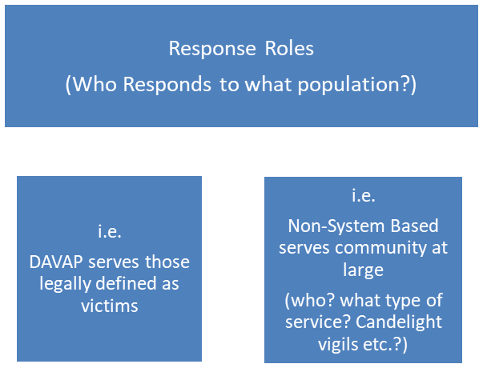

Victim Population Focused/Served: (This chart may be helpful in identifying roles)

Victim Population | (Your) DAVAP | OR DOJ  CVSD | FBI VSD | (Your LE Advocate) | Red Cross | (Others?)
Deceased Victims | X | X | X | X | X | X
Injured Victims | X | X | X | X | X | X
Direct/Non-Injured Victims | X | X | X | X | X | X
Near or On Location/Campus |  | X | Will be incident specific |  | X | X
Overall Community |  |  |  |  | X | X

System Based Points of Contact: (In addition to charts, consider including a separate detailed contact list like the one below and including definitions for acronyms)

Name: (Insert name)
Position/Agency: (Your county) Victim Assistance Program - Director
Office Phone: XXX-XXX-XXXX
Cell Phone: XXX-XXX-XXXX
Email: XXXXXXXXXX
Capabilities/Responsibilities:
- services related to direct victim needs
- interview accompaniment
- death notifications
- orientation to criminal justice center
- liaison between victim and law enforcement
- assistance with CVC applications
- future CJC events
- information and referral
- info disseminations
- facilitate victim assistance daily debriefs

Name: (Insert name)
Position/Agency: (Your county) Victim Assistance Program – Lead
Office Phone: XXX-XXX-XXXX
Cell Phone: XXX-XXX-XXXX
Email: XXXXXXXX
Capabilities/Responsibilities: same as above

Name: Helen O’Brien/Diane Wehage/Rebecca Shaw
Position/Agency: Oregon Department of Justice Crime Victims’ Services Division
Office Phone: XXX-XXX-XXXX
Cell Phone: XXX-XXX-XXXX
Email: XXXXXXX
Capabilities/Responsibilities:
- short and long term
- help with coordinating response from other DAVAPs
- activate CVSD response team
- activate CVC application
- help on-site with CVC app

Name: (Who is your contact?)
Position/Agency: Victim Specialist - FBI
Office Phone: XXX-XXX-XXXX
Cell Phone: XXX-XXX-XXXX
Email: XXXXXXX
Capabilities/Responsibilities:
- Coordination with law enforcement
  - in command center as needed
- Coordination with service providers
  - Resources
  - Family Assistance Center
- On-ground victim assistance
- Federal Funding (TEVAF) – incident specific
- Victim Services Response Team (VSRT) – incident specific

Name: (Insert name)
Position/Agency: (Your) Police Bureau
Office Phone: XXX-XXX-XXXX
Cell Phone: XXX-XXX-XXXX
Email: XXXXXX
Capabilities/Responsibilities:
- Immediate response
- Short-term follow up (up to 2 weeks)
- All volunteer
- Death notifications
- Connect with community resources

Name: (Anyone else?)
Position/Agency: XXXXX
Office Phone:
Cell Phone:
Email:
Capabilities/Responsibilities:
- County Contact for VIC/FAC
- Stands up FAC
- Psych first aid training
- Mobilize community contract
- Long term support
- Professional clinicians

Non-System Based Points of Contact

Name: (Insert name)
Position/Agency: XXXXXXX
Office Phone: XXX-XXX-XXXX
Cell Phone: XXX-XXX-XXXX
Email: XXXX
Capabilities/Responsibilities:
- Short and long term
- Cultural resource and language capacity
- Donation solicitation
- Emotional support
- Resources and referrals
- Crowd control
- Management of community events

Additional Main Points of Contact (non-committee) – add contact info
Medical Examiner- XXXXXX
College contacts - XXXXXX

Acronyms for Victim Assistance Response

(Your) County
- DAVAP – District Attorney Victim Assistance Program
- DA – District Attorney
- OEM – Office of Emergency Management

(Your) Police Bureau (XXX)
- CRT – Crisis Response Team

Oregon Department of Justice (DOJ)
- CVSD –Crime Victims’ Services Division
- CVC – Crime Victim Compensation

Federal Bureau of Investigation (FBI)
- VSRT– Victim Services Response Team
- VS – Victim Specialist
- VAP – Victim Assistance Program
- VSD – Victim Services Division

Additional Acronyms
- LE – Law Enforcement
- JIC – Joint Information Center
- CP – Command Post
- PIO – Public Information Officer (often Media component)

